FOR IMMEDIATE RELEASE CONTACT
Vanessa Coria, VP of Communications

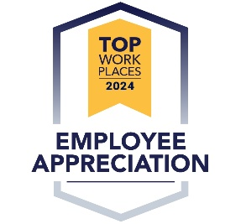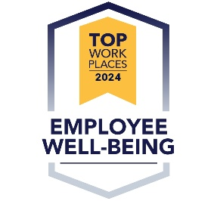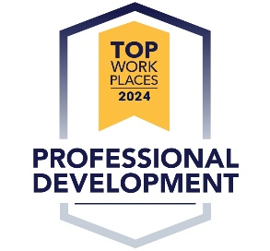

Salt Lake Tribune Names Chartway Winner of Utah Top Workplaces 2024 Award, Credit Union Also Honored with Fall Culture Excellence Awards
Press release courtesy of Energage

Virginia Beach, VA (October 15, 2024) – Chartway Credit Union has been awarded a Top Workplaces 2024 honor by Utah Top Workplaces for the fifth consecutive year and 2024 Top Workplaces Culture Excellence Awards for Appreciation, Professional Development, and Employee Wellbeing categories two years running. These lists are based solely on employee feedback gathered through a third-party survey administered by Energage LLC. The confidential survey uniquely measures the employee experience with themes such as feeling Respected & Supported, Enabled to Grow, and Empowered to Execute among others.

"At Chartway, our People First, Always philosophy is the foundation of our culture,” said Brian Schools, Chartway president and CEO. “We’re committed to creating an environment where team members feel empowered to grow, thrive, and make a meaningful difference. I’m proud of our team for their dedication to creating a culture where everyone belongs and this recognition shows the positive impact we have on our members, communities, and each other when we all work together.”

“Earning a Top Workplaces award is a badge of honor for companies, especially because it comes authentically from their employees,” said Eric Rubino, Energage CEO. “That's something to be proud of. In today's market, leaders must ensure they’re allowing employees to have a voice and be heard. That's paramount. Top Workplaces do this, and it pays dividends.”

In addition to the 2024 Top Workplaces award for Utah and the 2024 Top Workplaces Fall Culture Excellence awards, Chartway was awarded the national 2024 Top Workplaces USA award for the fourth consecutive year, the 2024 Top Workplaces Regional award for the Hampton Roads area six years running, and several 2024 Top Workplaces Spring Culture Excellence awards. The spring awards included recognition for Innovation, Work-Life Flexibility, Leadership, Compensation and Benefits, and Purpose and Values.

Learn more about job opportunities at Chartway Credit Union here.

Get the latest news about Chartway by visiting our media center.

About Chartway
Since 1959, Chartway has been unlocking the potential of individuals and families so they can thrive. Member-owned and values-driven, our $2.9 billion credit union proudly serves more than 230,000 members with branches in Utah, Texas, and Virginia. We’ve been recognized by Forbes as one of America’s Best-In-State Credit Unions, included on American Banker’s Top Credit Union to Work For list, and received numerous other top workplace and best credit union accolades. Reflecting a bright way forward, our charitable arm – the Chartway Promise Foundation – has granted nearly $15 million to provide medically fragile children and their families memorable experiences that bring joy, hope, and smiles. For information on our vibrant organization, please visit www.Chartway.com and follow us on Facebook, Twitter, and Instagram.

About Energage
Making the world a better place to work together.TM
Energage is a purpose-driven company that helps organizations turn employee feedback into useful business intelligence and credible employer recognition through Top Workplaces. Built on 18 years of culture research and the results from 27 million employees surveyed across more than 70,000 organizations, Energage delivers the most accurate competitive benchmark available. With access to a unique combination of patented analytic tools and expert guidance, Energage customers lead the competition with an engaged workforce and an opportunity to gain recognition for their people-first approach to culture. For more information or to nominate your organization, visit energage.com or topworkplaces.com.

# # #

